Appendix 3E: Evaluating Alternative Assessment Structures for Alaska Sablefish Under Survey Design Changes via Closed-Loop Simulation
Matthew LH. Cheng, Daniel R. Goethel, Pete J. Hulson, Curry J. Cunningham

Introduction
Alaska sablefish in federal waters are managed across six fishery management areas spanning the Gulf of Alaska (GOA), Aleutian Islands (AI), and Bering Sea (BS), with management advice derived from a panmictic stock assessment model. Consequently, the assessment is both complex and unique among assessed Alaska groundfish species in that it encompasses the full spatial extent of federal management areas. Under this framework, data sources (e.g., abundance indices and age- and length-compositions) are aggregated across spatial regions to represent population-wide sampling processes and dynamics. As a result, assessment of Alaska sablefish depends on synoptic sampling coverage across fishery and survey fleets to ensure that aggregated data streams remain representative of population-wide trends.
A primary data source informing the assessment model is the NOAA domestic longline survey, a sablefish dedicated cost-recovery survey that provides representative abundance indices of sablefish across their Alaskan range (1996–2026), along with composition data to characterize population age structure and recruitment dynamics. Historically, the survey sampled the GOA annually while alternating between the BS and AI in odd and even years, respectively. Abundance indices in unsampled regions were interpolated using the proportional change observed between consecutive years in the GOA, while composition data were aggregated only across sampled regions. Such an approach is likely reasonable when trends in the GOA are representative of other regions or when abundance in unsampled regions is comparatively low (as was the case historically). However, recent changes in the economic conditions of the Alaska sablefish fishery rendered cost recovery infeasible, necessitating modifications to the existing survey design to accommodate potential operating losses. Starting in 2025, the domestic longline survey was modified to sample the GOA during odd years and the BS and AI during even years.
Such a substantial change to one of the most informative data sources for the Alaska sablefish assessment has prompted several lines of inquiry. First, if the survey is no longer synoptic, how can population-wide abundance indices and age compositions be constructed for use within a panmictic assessment framework? This concern is compounded by recent recruitment dynamics, which suggest that large recruitment events originate primarily from the BS and AI, with approximately 50% of the population biomass residing in these regions in any given year. As a result, both conditions under which historical interpolation was considered reasonable have likely degraded: abundance in unsampled regions is no longer comparatively low, and GOA trends are unlikely to be representative of population-wide dynamics. Thus, the extent to which historical interpolation methods used to impute unsampled regions can continue to provide reliable population-wide information remains questionable. Given the aforementioned complications, two questions arise: first, to what extent does fitting spatially incomplete data and historical interpolation within a panmictic framework compromise assessment performance, and second, can alternative model structures that accommodate data at the spatial scale at which they were collected offer improved model performance? In the following sections, we use a complementary simulation-testing framework (i.e., cross-testing and closed-loop simulations) based on a five-region model of Alaska sablefish (Cheng et al. 2025) to directly evaluate these questions by comparing the performance of alternative model structures when confronted with a change in survey design.
Methods
We first describe the three alternative model structures considered, followed by a description of the simulation testing framework used to evaluate their performance.

General Description of Alternative Model Structures Considered
We considered three model structures in our simulation-testing framework: (1) a single-region panmictic model serving as a baseline that closely mimics the existing operational stock assessment, (2) a fleets-as-areas (FAA) model, and (3) a spatial model. The latter two represent alternative structures that accommodate data at the spatial scale at which they are collected, rather than requiring aggregation to a population-wide level. Below, we provide general descriptions of each.

The single-region model closely mimicked the operational stock assessment model (Goethel and Cheng 2024; Appendix 3A and 3B). It was sex- and age-structured, modelled removals from two fishery fleets (longline and trawl), and was further informed by two survey fleets (the contemporary domestic longline survey and a historical Japanese longline survey). The longline fishery was assumed to follow logistic selectivity, whereas the trawl fishery followed dome-shaped gamma selectivity. Both survey fleets were assumed to follow logistic selectivity patterns.
FAA models are widely used to accommodate spatial heterogeneity by allowing fleet-specific dynamics to implicitly capture variation in spatial availability. In such formulations, spatial structure is not explicitly modelled; instead, spatial heterogeneity in population dynamics is represented through fleet-specific catchability and selectivity processes. In the case of Alaska sablefish, an FAA model was further considered given its ability to potentially accommodate spatially incomplete data. Given that an FAA model has not previously been applied to Alaska sablefish, limited guidance was available to inform its specification. We therefore used a cross-testing simulation framework to first identify a robust FAA model structure prior to further evaluation in a closed-loop simulation setting (further described below).
The third model structure explicitly represented spatial population dynamics to directly leverage regionally collected data, as well as the wealth of tagging data to inform movement estimation avaialbe for Alaska sablefish. In general, this spatial model closely followed the parameterization of Cheng et al. (2025) and Appendix 3D with the exception that three regions (BS, AI, and GOA) were modeled rather than five. Recruitment was assumed to arise from regional mean recruitment with spatially and temporally varying lognormal deviations. In addition, all demographic rates (e.g., natural mortality, growth, and maturity) were assumed to be constant across both space and time. Movement was modeled as an unstructured Markov process with three age blocks representing young (ages 2–7), intermediate (ages 8–15), and old (ages 16–31) individuals, to approximately capture ontogenetic movement dynamics.
Simulation Testing Framework
The simulation testing framework used here employed a two-stage approach. In the first stage, we conducted simulation cross-testing to identify a robust FAA model structure for Alaska sablefish, given that no prior FAA formulation exists on which to base model specification. In the second stage, we conducted closed-loop simulations using the three model structures described above to evaluate: 1) potential biases resulting from mismatches in spatial structure, 2) the impacts of changes in survey design on assessment performance, and 3) the robustness of management advice produced by each model under spatial and survey design uncertainty. In both stages, the operating model (OM) was conditioned using estimates from a five-region spatial stock assessment model parameterized via Cheng et al. (2025) and Appendix 3D.
Stage 1: Cross Testing Fleets-as-Areas Models
Simulation cross-testing is widely used to evaluate model robustness under varying degrees of model misspecification (Deroba et al. 2015). In general, cross-testing involves an OM representing the true system dynamics that is used to generate data to which various estimation models (EMs) are fitted. Outputs from the OM therefore provide the basis for comparison, allowing evaluation of how well different EMs are able to reproduce the underlying system dynamics despite model misspecification, while also highlighting the relative strengths and limitations of alternative model structures.
As previously mentioned, the OM forming the basis of this work was conditioned on estimates from the five-region spatial stock assessment model encompassing the BS, AI, western GOA (WGOA), central GOA (CGOA), and eastern GOA (EGOA) (see Cheng et al. 2025 for further details). The OM was sex-and age-structured and assumed age-varying ontogenetic movement dynamics, with younger individuals residing in western regions, moving eastward as they matured. Additionally, the OM generated region- and fleet-specific data streams, including fishery catch, survey abundance indices, and both fishery and survey age-composition data across each spatial region and fleet considered in the assessment framework. Fishery catches were simulated assuming a lognormal distribution with a standard deviation of 0.05, while composition data were all simulated with a multinomial likelihood, with an input sample size of 20 for each region. Survey abundance indices were also simulated with a lognormal distribution, with a standard deviation of 0.2. Fleets included the longline fishery, trawl fishery, domestic longline survey, and historical Japanese longline survey.
To identify a FAA model structure for use in subsequent simulations that was robust to mis-specified spatial structure, and to inform the specification of a potential operational FAA assessment model, a semi-factorial design was implemented. This design varied across three key dimensions relevant to spatial sablefish dynamics: 1) fishery fleet structure, 2) longline fishery selectivity, and 3) domestic longline survey selectivity. While not exhaustive, these factors captured the primary structural decisions required to accommodate key spatial processes while maintaining a tractable number of model combinations.
A total of four alternative fishery fleet structures were considered, ranging from fully aggregated to fully disaggregated representations of the longline and trawl fisheries. The first configuration treated both fisheries as single aggregated fleets across all regions. The second configuration disaggregated the longline fishery into BS, AI, and GOA fleets while retaining a single aggregated trawl fleet. The third configuration further disaggregated the trawl fishery into a BS fleet and a combined AI/GOA fleet. The fourth configuration fully disaggregated both fisheries into BS, AI, and GOA fleets, yielding six total fishery fleets.
Fishery selectivity parameterizations were explored through several alternative configurations that varied in the extent to which dome-shaped selectivity was permitted across longline fishery fleets. Specifically, four configurations were considered: 1) all longline fleets parameterized with asymptotic logistic selectivity, 2) all longline fleets parameterized with dome-shaped gamma selectivity, 3) only the BS longline fleet parameterized with dome-shaped gamma selectivity while remaining fleets retained logistic selectivity, and 4) both the BS and AI longline fleets parameterized with dome-shaped gamma selectivity while remaining fleets retained logistic selectivity. The trawl fishery fleet was consistently parameterized using gamma selectivity across all configurations, consistent with the current operational assessment model and its relatively small contribution to total catch, as well as its tendency to harvest smaller individuals.
Survey selectivity parameterizations followed an analogous structure for the domestic longline survey. Four configurations were considered: 1) all domestic survey fleets parameterized with asymptotic logistic selectivity, 2) all domestic survey fleets parameterized with gamma selectivity, 3) only the BS domestic survey fleet parameterized with gamma selectivity while the AI and GOA survey fleets retained logistic selectivity, and 4) both the BS and AI domestic survey fleets parameterized with gamma selectivity while the GOA survey fleet retained logistic selectivity. The historical Japanese longline survey was consistently parameterized with asymptotic logistic selectivity across all configurations, reflecting prior assumptions regarding its selectivity and maintaining consistency with the operational assessment model.
The intention of allowing gamma (dome-shaped) selectivity in select fishery and survey fleets was to reflect expected spatial heterogeneity in population age and size structure arising from ontogenetic movement and spatial asynchrony in recruitment patterns. In particular, BS and AI regions tend to represent a relatively higher proportion of younger individuals (likely to be more domed), whereas GOA regions are more strongly dominated by larger, older fish (i.e., likely to be more logistic).
Note that the survey fleets maintained the same fleet structure across all simulations, reflecting the primary objective of the FAA framework to accommodate the revised survey design and to explicitly handle spatially incomplete observations. The domestic longline survey was therefore represented as three region-specific fleets corresponding to BS, AI, and GOA (with WGOA, CGOA, and EGOA combined), while the Japanese survey was represented as a single aggregated fleet. Taken together, these specifications resulted in 56 estimation models evaluated in the cross-testing experiment (some fleet structures are not compatible with all selectivity options; e.g., 1 longline fishery fleet and 1 trawl fleet).
Model Evaluation
To identify a robust FAA model formulation among the 56 alternatives explored, we compared relative bias in estimates of spawning stock biomass (SSB), alongside convergence rates across models. These results were evaluated alongside a priori considerations of model performance, biological realism, with additional attention to implications for model stability (i.e., model convergence). A total of 100 simulations were conducted for this exercise.

Stage 2: Closed-Loop Simulation Framework
Complementing the cross-testing simulation framework used to identify a robust FAA model, closed-loop simulations were conducted to evaluate the effects of data interpolation within a single-region model on management performance, as well as the potential benefits of employing EMs capable of accommodating spatially incomplete data. Briefly, closed-loop simulations are analogous to management strategy evaluations (MSEs), in which an OM is specified to represent the true underlying system dynamics. The OM generates monitoring data that are subsequently used within EMs. The EMs are then fit to the monitoring data and provide estimates of key management quantities (e.g., SSB), which are subsequently incorporated within a harvest control rule (HCR) to generate catch advice. The resulting catch advice is then fed back into the OM to simulate removals in subsequent years, thereby completing the feedback loop (Punt et al. 2016). This process continues iteratively through time. Such an approach has been widely applied and is particularly useful in this context for evaluating the potential impacts of alternative EMs on management advice.

Similar to the cross-testing simulation framework, the OM was conditioned on estimates from a sex-and age-structured five-region spatial model (Cheng et al. 2025), parameterized with age-varying movement dynamics. The OM generated fishery catches, fishery age and length compositions, survey age and length compositions, survey abundance indices, and tagging data for use in a spatial stock assessment model. Fishery catches were simulated assuming a lognormal distribution with a standard deviation of 0.05, while all composition datasets were simulated using a multinomial likelihood with an input sample size of 20 for each region. Similarly, survey abundance indices were simulated assuming a lognormal likelihood with a standard deviation of 0.2. Tagging data were simulated using a multinomial release-conditioned likelihood, assuming 2,000 tags released per tagging cohort, corresponding approximately to the average across all tag release events. Future recruitment dynamics within the OM were simulated by jointly resampling a vector of recruitment values from a given year, thereby preserving potential spatial correlation in recruitment dynamics among regions (Fig. 3E.1 and 3E.2). A total of 30 closed-loop projection years were simulated following the terminal year of the conditioning period.
A total of three EMs and one ‘reference’ model were evaluated within the closed-loop simulation framework. The ‘reference’ model was used as a baseline for comparison, and was based on the true values of the OM. To evaluate the management performance of the existing single-region stock assessment model, as well as the implications of aggregating spatially incomplete data, the first EM was parameterized to mimic the operational single-region stock assessment model. Under this configuration, all data were aggregated into a single-region model. Under the alternating survey design (i.e., data prior to the projection period), unsampled regions in the survey abundance indices were imputed using carryover values from the most recent year in which those regions were sampled. Similarly, age-composition data were aggregated by combining catch-weighted compositions across sampled regions. Following the change in survey design, the same interpolation approach was applied during the closed-loop projection period. However, because fewer regions were sampled under the revised design, a greater proportion of the survey abundance indices required imputation.
Leveraging insights from the cross-testing simulation framework, the second EM was a FAA parameterized model to evaluate the general performance of models capable of accommodating spatially incomplete data. Within the FAA model, survey fleets were generally treated as spatially disaggregated. Data from the BS and AI regions were fit directly, whereas data from the GOA were aggregated across the WGOA, CGOA, and EGOA regions. Specifically, GOA abundance indices were summed across regions, while GOA age-composition data were combined using catch-weighted aggregation. Missing observations were treated explicitly as missing data, and therefore no interpolation of unsampled regions was required. Aggregation or disaggregation of fishery fleet data follows the most robust structure identified in the cross-testing simulation framework.
The third EM was a three-region spatially-explicit model, with regions analogous to the FAA model (i.e., BS, AI, and GOA regional structure). As in the FAA model, data from the BS and AI regions were fit directly, while those from the GOA were aggregated across the WGOA, CGOA, and EGOA regions. The model followed the general parameterization of the five-region OM (Cheng et al. 2025), with the exception of the reduced regional structure. Age-varying movement dynamics were specified and tagging data were integrated into the model. Missing observations were again treated explicitly as missing data, with no interpolation applied.
A five-region “reference” model was also parameterized and used as a reference case for comparison. Specifically, this model was based directly on the OM and therefore assumed full knowledge of the underlying system dynamics. As such, it represents an upper-bound case in which management is conditioned on perfect information, providing an informative benchmark for evaluating the performance of the alternative EMs. A five-region EM was not further considered as a candidate EM due to the greater parsimony of the three-region formulation, which is expected to yield comparable performance, as well as large computational constraints associated with the closed-loop simulation framework.
As part of the closed-loop simulation framework, each model provides catch advice that is subsequently fed back into the OM to simulate removals. In general, catch advice in Alaska is based on estimates of SSB and a threshold harvest control rule HCR, in which B40% is used as the reference point for adjusting fishing intensity (i.e., if SSB > B40%, fishing occurs at F40%; otherwise, fishing mortality declines linearly with decreasing SSB). However, SSB estimates and resulting catch advice are generated on different spatial scales across models and are not directly consistent with the five-region spatial structure of the OM.
In the case of the single-region and FAA models, SSB and B40% are estimated on an Alaska-wide basis, and a corresponding Alaska-wide fishing mortality rate is derived. This rate is applied in a projection model to generate total Alaska-wide catch. These catches are subsequently apportioned to the management units using a five-year rolling average of survey biomass proportions by region, with missing years and regions imputed using values from previous sampled years. Regionally apportioned catches are then distributed to the longline and trawl fleets using pre-specified gear allocation rates (NPFMC 2024b, 2024a).
By contrast, the three-region and five-region spatially explicit models produce spatially explicit estimates of SSB. To maintain consistency in the application of the harvest control rule, regional SSB estimates are aggregated to an Alaska-wide total and compared to an Alaska-wide B40% reference point, defined using global spawning potential ratio (SPR). The associated F40% is then applied uniformly across regions in the projection model, such that attainment of B40% is evaluated at the Alaska-wide scale (i.e., comparison of SSB to B40%) while exploitation is implemented regionally. This yields spatially explicit catch advice, which is then distributed to longline and trawl fleets using pre-specified gear allocation rates (NPFMC 2024b, 2024a). For the three-region model, projected catches from the GOA are subsequently apportioned across the WGOA, CGOA, and EGOA using a five-year rolling average of survey biomass proportions, consistent with the single-region and FAA approaches. Note that projection of regional catch advice can also be derived by comparing regional SSB quantities to local reference points to obtain local fishing mortality rates. However, this approach was not undertaken to maintain comparability across all models.
Model Evaluation
The performance of the alternative EMs was evaluated relative to the five-region reference model, which served as the “true” model. Comparisons were made between emergent trajectories of SSB and catch from each EM and those from the five-region reference model, at both regional and Alaska-wide scales. For the three simplified EMs (i.e., the single-region, FAA, and three-region models), relative error in SSB was additionally examined across closed-loop years to understand the drivers of observed differences in SSB and catch trajectories and to assess potential bias associated with implementing these models in a management context. Simulations were conducted until approximately 100 converged replicates were obtained for each projection year, where a converged replicate was defined as a full 30-year simulation in which all model components successfully converged; non-converged replicates were discarded.
Results
Cross-testing simulations of FAA models revealed several insights regarding robust model configurations. In general, most models demonstrated good convergence rates (~90 – 100%). Consistent with the findings of previous studies, assuming dome-shaped gamma selectivity for all fishery and survey fleets resulted in large positive biases in SSB across all fishery fleet structures, likely due to the estimation of substantial cryptic biomass (Fig. 3E.3). Conversely, assuming logistic selectivity for all fishery fleets produced persistent negative biases under configurations with multiple longline and trawl fleets (Fig. 3E.3). Despite these biases, certain configurations were effective in mitigating error. In particular, the combination of three longline fleets (BS, AI, and GOA) and one trawl fleet, coupled with certain fleets assuming dome-shaped selectivity, exhibited relatively small biases (~5%) (Fig. 3E.4). Similarly, the simplest configuration with a single longline and single trawl fishery fleet, combined with logistic selectivity across all survey fleets also performed robustly. Presumably, the lack of a FAA structure in the fishery appears to perform robustly because a large proportion of total catch is derived from the GOA, with relatively minor contributions from other regions. In addition, disaggregation in the survey fleets may be sufficient to capture spatial heterogeneity in population age structure, thereby reducing the need for explicit fishery fleet disaggregation. Nevertheless, the FAA model configuration that exhibited the least median SSB bias across the entirety of the time-series was 3 longline and 1 trawl fishery fleet, coupled with fishery and survey selectivity assumed to be dome-shaped in the BS, and logistic elsewhere. In subsequent closed-loop simulations, this least biased FAA model configuration will be used and notes as the FAA model.

Application of alternative EMs in closed-loop simulations indicated that, regardless of model structure, trajectories of regional and Alaska-wide SSB were broadly similar (Fig. 3E.5 and 3E.6). However, some differences were evident among EMs. In particular, the three-region spatially explicit model produced the highest SSB during the early period of the projection, followed by the lowest SSB toward the end of the simulation period. The single-region model generally yielded the second-lowest SSB across the time series, whereas the FAA and five-region models exhibited similar trends and magnitudes throughout the projection period (Fig. 3E.5 and 3E.6).

Differences in catch levels generally reflected SSB trends, with periods of higher SSB generally associated with lower realized catch levels (Fig. 3E.7 and 3E.8). However, in contrast to SSB trajectories, regional catch levels were more variable among EMs. In particular, the FAA and single-region models produced higher catch levels in the BS and AI, and lower catch levels in the GOA regions, during the initial portion of the projection period, whereas the spatial model variants exhibited the opposite pattern. During the later portion of the projection period, the three-region model tended to produce the highest catch levels despite exhibiting lower catches initially. In general, all EMs prescribed higher catch levels during the final years of the projection period relative to the five-region reference model. Differences among models in regional catch trajectories likely reflected the distinct apportionment methods used by each EM.

Trends in SSB and catch levels that emerged from these closed-loop simulations can generally be explained by biases inherent to each EM (Fig. 3E.9). All models tended to underestimate SSB during the initial projection period, which translated to lower realized catch and higher SSB levels relative to the five-region baseline comparison. In general, the magnitude of underestimation was greatest for the three-region model, followed by the single-region and FAA model. Toward the end of the time-series, positive biases were evident across all EMs, again with the largest magnitude occurring in the three-region model, followed by the single-region and FAA model. Accordingly, catch levels tended to be overprescribed relative to the five-region reference model (Fig. 3E.9), which subsequently translated into lower SSB levels. Biases in the single-region model were likely attributable to the aggregation of spatially incomplete data, whereas biases in the FAA model were primarily associated with insufficient flexibility in survey selectivity to account for spatial changes in availability arising from ontogenetic movement and recruitment dynamics. Lastly, biases in the three-region model were most likely driven by model instability associated with recruitment, movement, and their related confounding effects. In particular, recruitment estimates occasionally shifted markedly among years, with some regions in certain years estimating unrealistically low recruitment levels approaching zero (not shown), while the same regions in other years estimated substantially higher recruitment levels. These dynamics likely contributed to both positive and negative biases and indicate that the three-region model likely requires careful tuning to achieve stable behavior in an operational context. Thus, simple ‘update’ assessments would likely not be feasible given the potential need to refine the model within each assessment cycle.

Taken together, results from this complementary simulation-testing framework provide important context for considering alternative models for management use. In particular, none of the EMs considered here resulted in detrimental management outcomes (i.e., depletion of SSB to exceedingly low levels), despite the various biases that were evident (Fig. 3E.9). Moreover, while spatial models were, in theory, more biologically plausible, they were also generally less stable, subject to greater data demands, and likely required more analyst tuning in an operational context. Important trade-offs associated with model development time, model learning, and implementation under a spatial framework should therefore also be considered when evaluating spatial models for management applications. By contrast, both the single-region and FAA models demonstrated greater model stability. While the FAA model tended to exhibit the least bias of the EMs considered, additional consideration with respect to model stability may still be required (given the addition of new parameters) when applied to real-world data.

References
Cheng MLH, Marsh CA, Goethel DR et al. Panmictic Panacea? Demonstrating Good Practices for Developing Spatial Stock Assessments Through Application to Alaska Sablefish ( Anoplopoma fimbria ). Fish and Fisheries 24 Jun. 2025:faf.70002. https://doi.org/10.1111/faf.70002.
Deroba JJ, Butterworth DS, Methot RD et al. Simulation testing the robustness of stock assessment models to error: some results from the ICES strategic initiative on stock assessment methods. ICES Journal of Marine Science 2015;72(1):19–30. https://doi.org/10.1093/icesjms/fst237.
Goethel DR, Cheng ML. 3. Assessment of the Sablefish Stock in Alaska. 2024:119.
NPFMC. STOCK ASSESSMENT AND FISHERY EVALUATION REPORT FOR THE GROUNDFISH RESOURCES OF THE BERING SEA/ALEUTIAN ISLANDS REGIONS. 2024. https://www.npfmc.org/wp-content/PDFdocuments/SAFE/2024/BSAIintro.pdf.
NPFMC. STOCK ASSESSMENT AND FISHERY EVALUATION REPORT FOR THE GROUNDFISH RESOURCES OF THE GULF OF ALASKA. 2024. https://www.npfmc.org/wp-content/PDFdocuments/SAFE/2024/GOAintro.pdf.
Punt AE, Butterworth DS, Moor CL de et al. Management strategy evaluation: best practices. Fish Fish 2016;17(2):303–34. https://doi.org/10.1111/faf.12104.

Figures

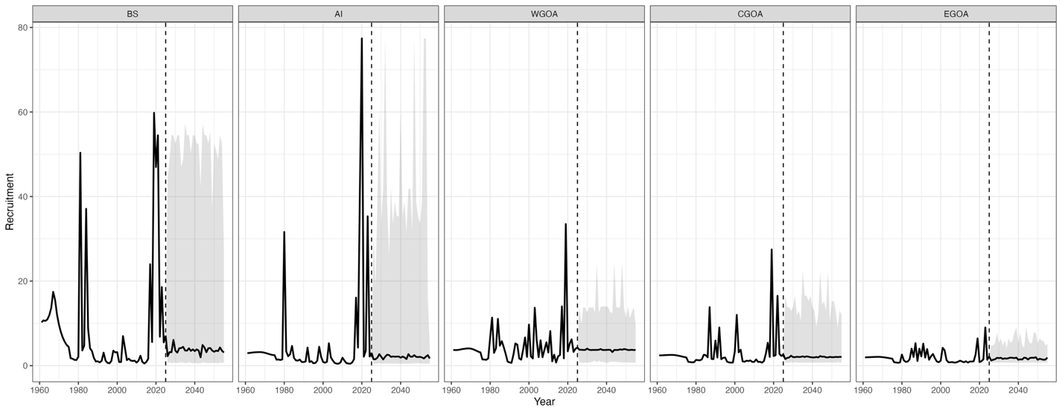
Figure 3E.1. Median trajectories and associated 95% simulation intervals of regional recruitment in the closed-loop simulation framework. Column panels denote regions and the dashed vertical line depicts the start of the closed-loop projection period. Values to the left of the dashed line represent the historical conditoning period.

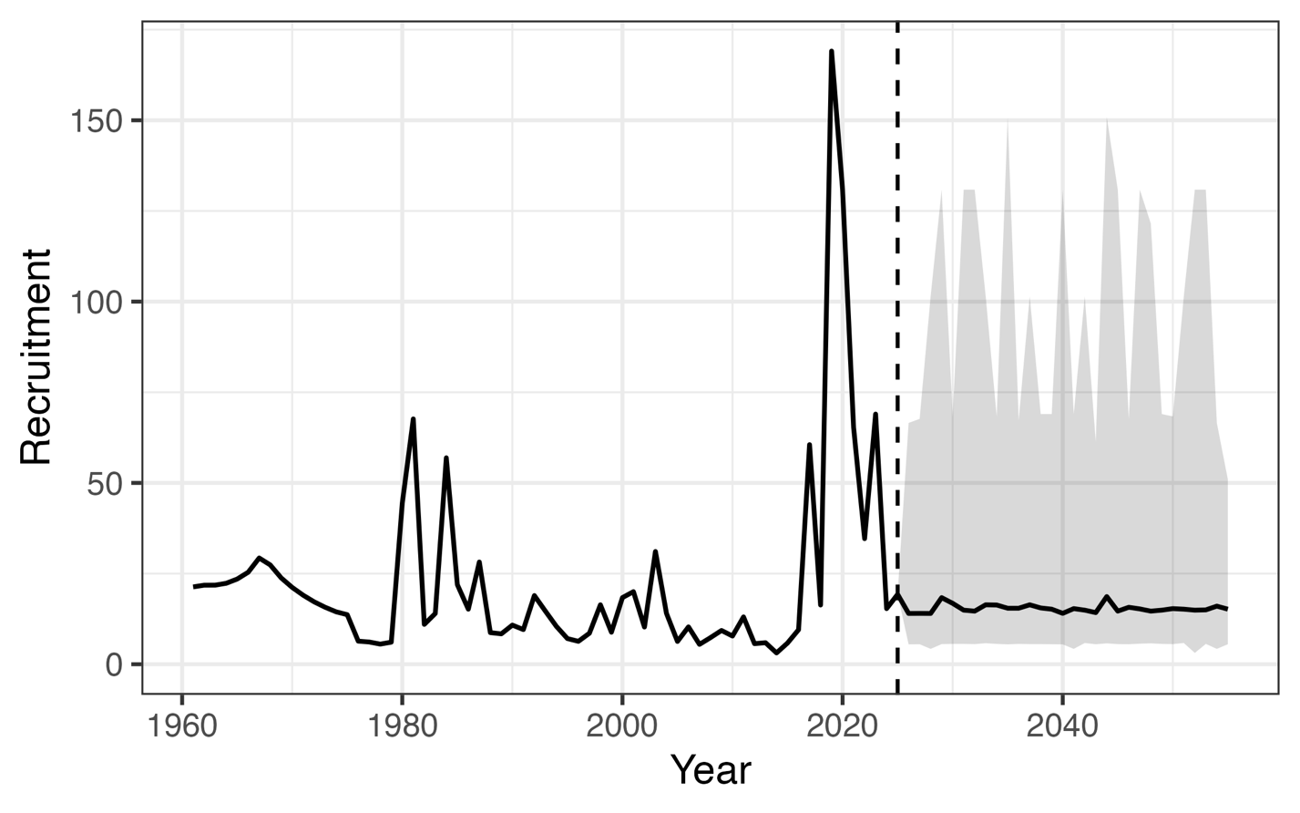
Figure 3E.2. Median trajectories and associated 95% simulation intervals of Alaska-wide recruitment in the closed-loop simulation framework. The dashed vertical line depicts the start of the closed-loop projection period. Values to the left of the dashed line represent the historical conditoning period.

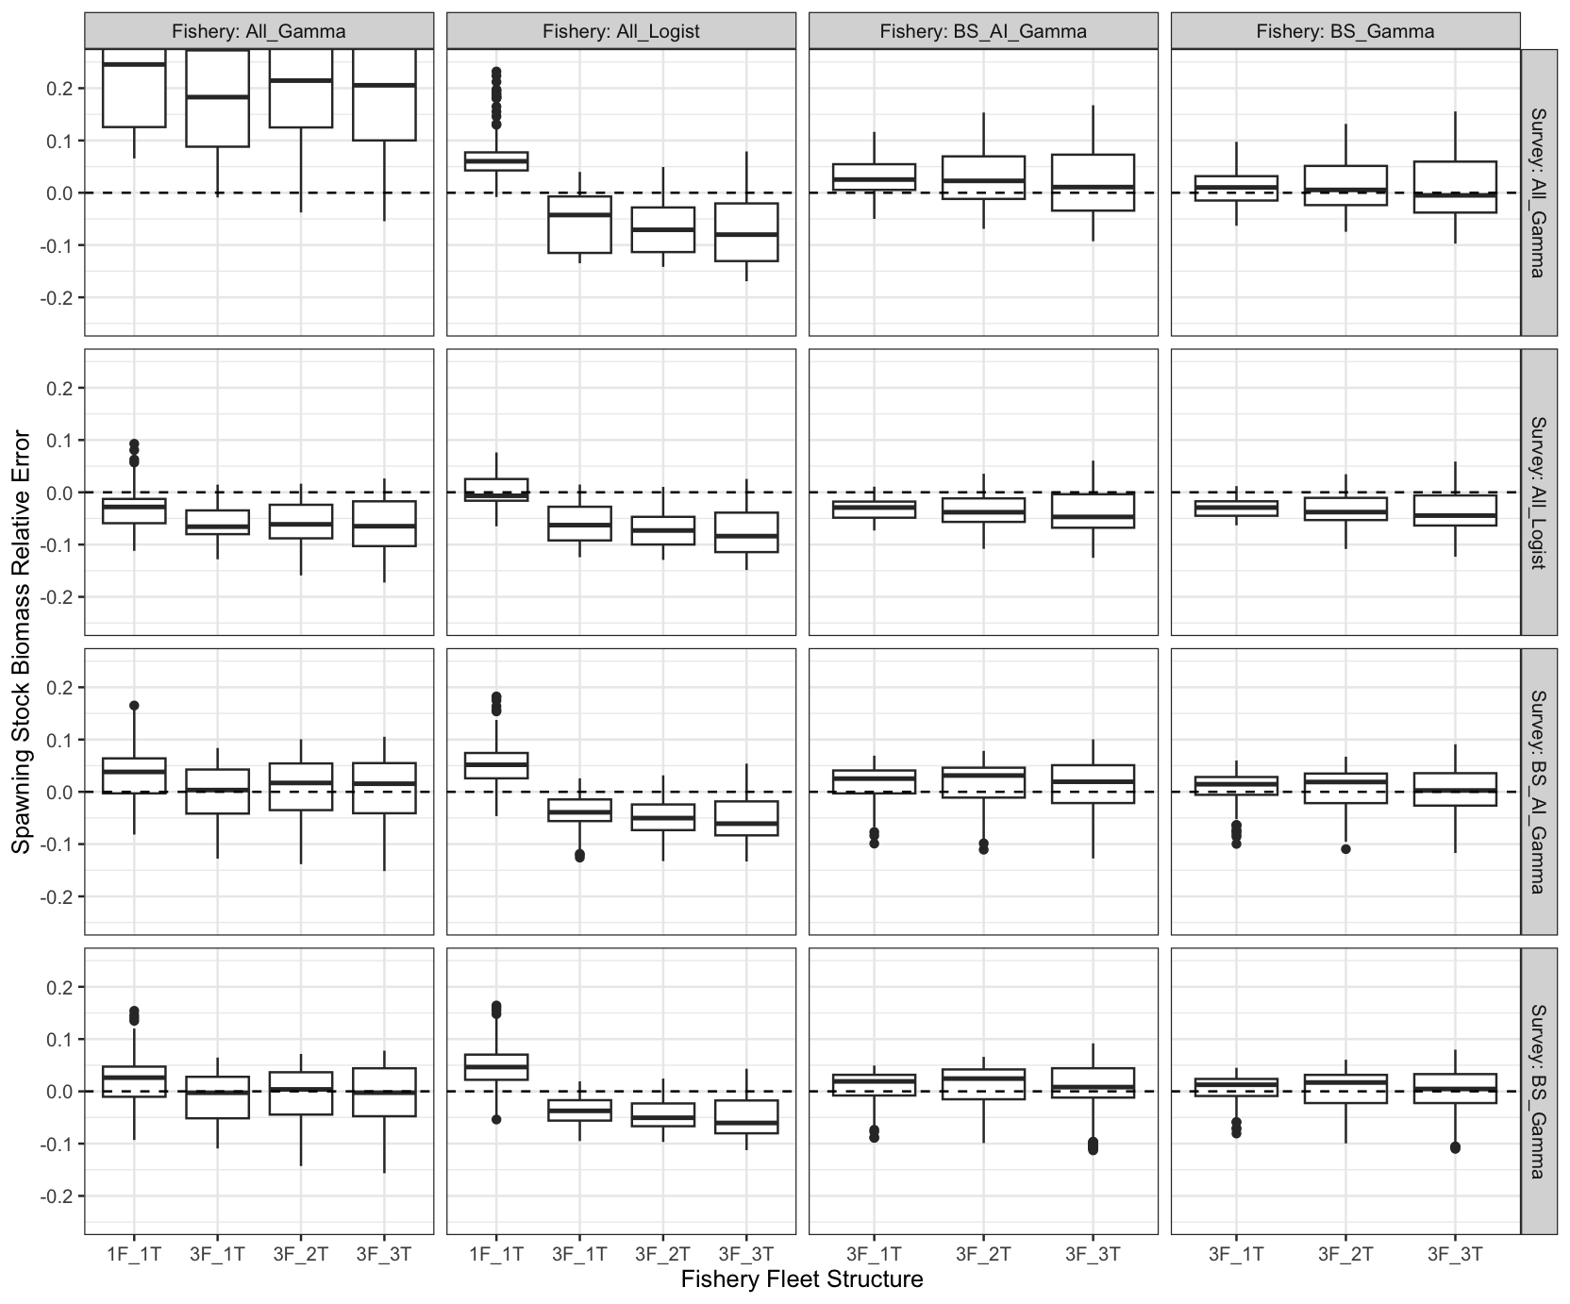
Figure 3E.3. Relative error in spawning stock biomass (SSB) across fleets-as-areas (FAA) model configurations evaluated in the cross-testing simulation framework, shown as boxplots. The x-axis denotes fishery fleet structures considered; column panels represent alternative fishery selectivity parameterizations; and row panels represent alternative survey selectivity parameterizations. The dashed horizontal line indicates zero relative bias. Fishery fleet structures are defined as follows: 1F_1T represents a single longline fleet and a single trawl fleet; 3F_1T represents three longline fleets (BS, AI, GOA) and one trawl fleet; 3F_2T represents three longline fleets (BS, AI, GOA) and two trawl fleets (BS+AI, GOA); and 3F_3T represents three longline fleets (BS, AI, GOA) and three trawl fleets (BS, AI, GOA). Longline fishery and domestic longline survey selectivity configurations are defined as follows: All_Gamma denotes gamma selectivity for all fleets; All_Logist denotes logistic selectivity for all fleets; BS_AI_Gamma denotes gamma selectivity for BS and AI fleets with logistic selectivity elsewhere; and BS_Gamma denotes gamma selectivity for BS fleets with logistic selectivity elsewhere.
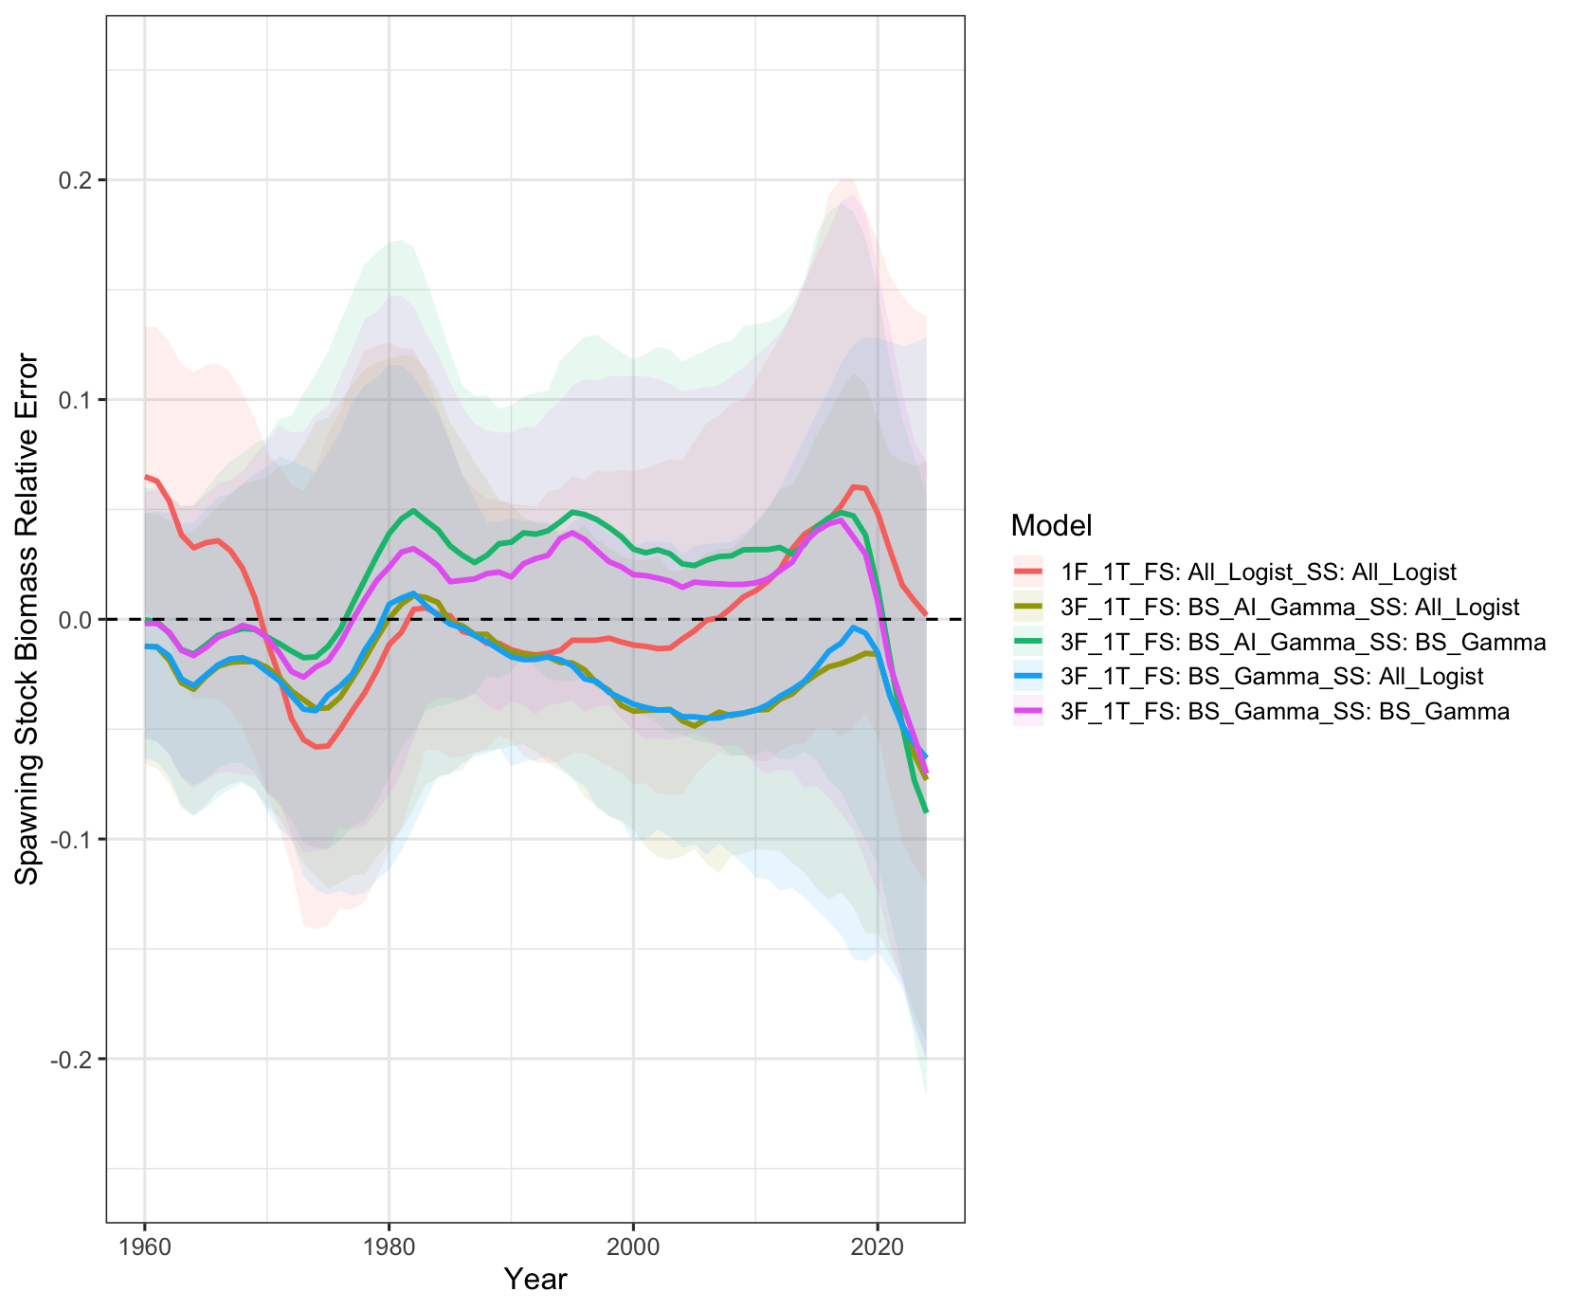
Figure 3E.4. Time-series of relative error in spawning stock biomass (SSB) across fleets-as-areas (FAA) model configurations evaluated in the cross-testing simulation framework. Solid lines denote the median, while shaded regions represent 95% simulation intervals. Fishery fleet structures are defined as follows: 1F_1T represents a single longline fleet and a single trawl fleet; 3F_1T represents three longline fleets (BS, AI, GOA) and one trawl fleet. Longline fishery (FS) and domestic longline survey selectivity (SS) configurations are defined as follows: All_Logist denotes logistic selectivity for all fleets; BS_AI_Gamma denotes gamma selectivity for BS and AI fleets with logistic selectivity elsewhere; and BS_Gamma denotes gamma selectivity for BS fleets with logistic selectivity elsewhere. The purple line depicts the model that exhibits the least median SSB bias across the entirety of the modelled time-series.

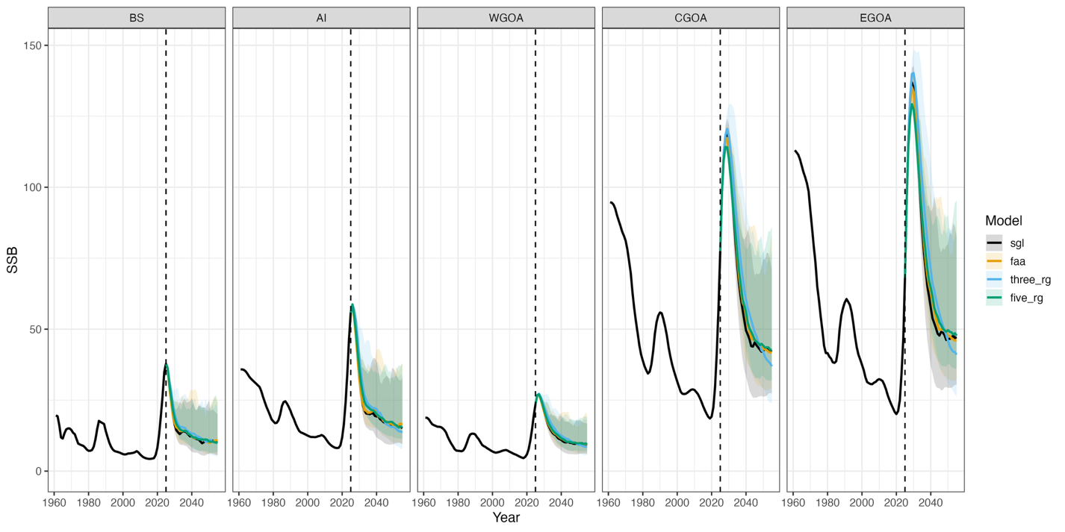
Figure 3E.5. Median trajectories and associated 95% simulation intervals of regional spawning stock biomass (SSB) resulting from the application of different estimation models (EMs; colors) in the closed-loop simulation framework. Column panels denote regions, colors represent different EMs applied, and the dashed vertical line depicts the start of the closed-loop projection period. Values to the left of the dashed line represent the historical conditoning period. Model names are as follows: sgl represents a single-region model, faa represents the best fleets-as-areas model, three_rg represents the three-region spatially explicit model, and five_rg denotes the five-region reference model .

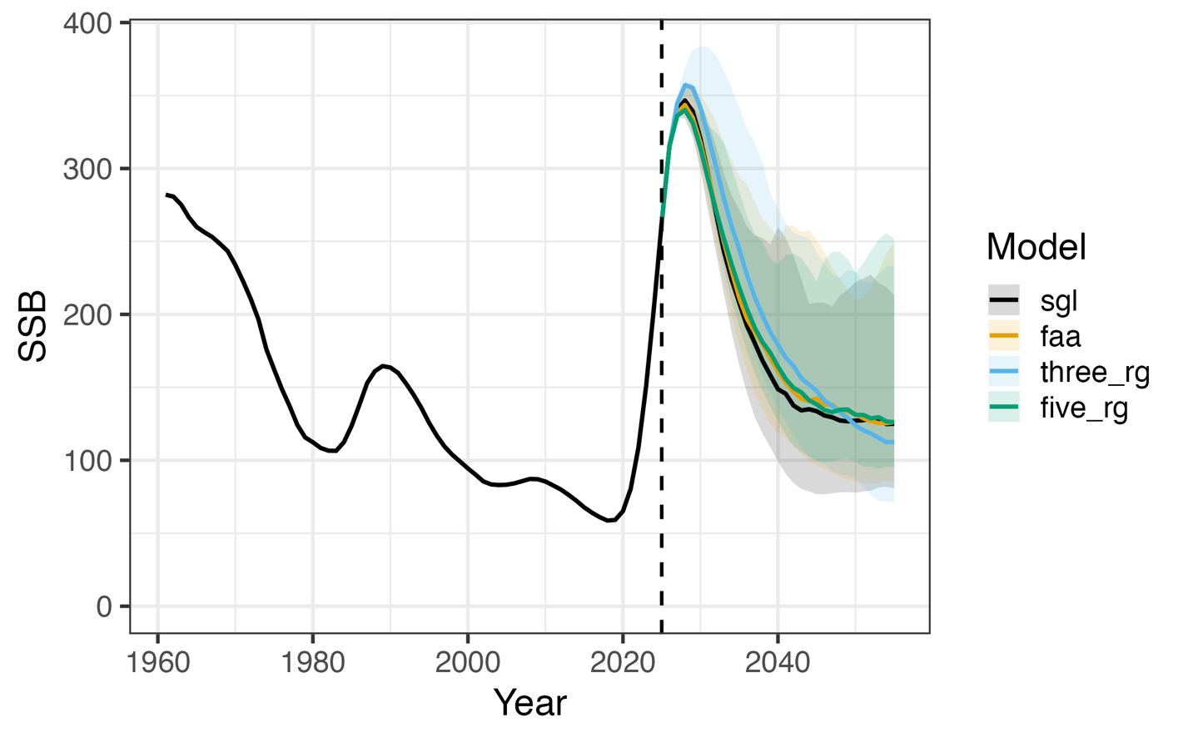
Figure 3E.6. Median trajectories and associated 95% simulation intervals of Alaska-wide spawning stock biomass (SSB) (summed across regions) resulting from the application of different estimation models (EMs; colors) in the closed-loop simulation framework. The dashed vertical line depicts the start of the closed-loop projection period. Values to the left of the dashed line represent the historical conditoning period. Model names are as follows: sgl represents a single-region model, faa represents a fleets-as-areas model, three_rg represents the three-region model, and five_rg denotes the five-region reference model .

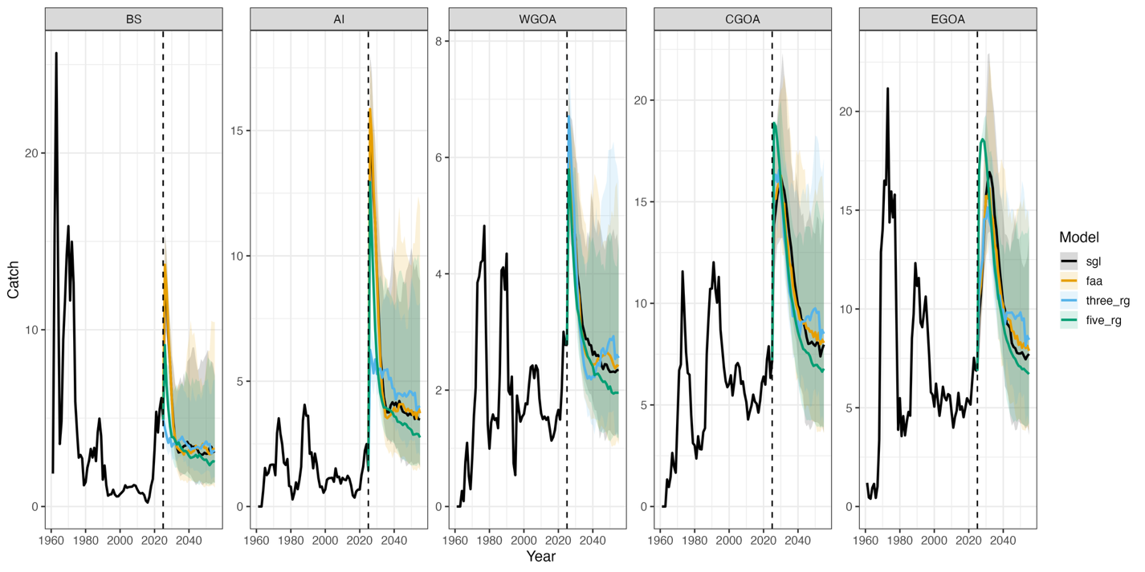
Figure 3E.7. Median trajectories and associated 95% simulation intervals of regional catch (summed across fleets) resulting from the application of different estimation models (EMs; colors) in the closed-loop simulation framework. Column panels denote regions, colors represent different EMs applied, and the dashed vertical line depicts the start of the closed-loop projection period. Values to the left of the dashed line represent the historical conditoning period. Model names are as follows: sgl represents a single-region model, faa represents a fleets-as-areas model, three_rg represents the three-region model, and five_rg denotes the five-region reference model .
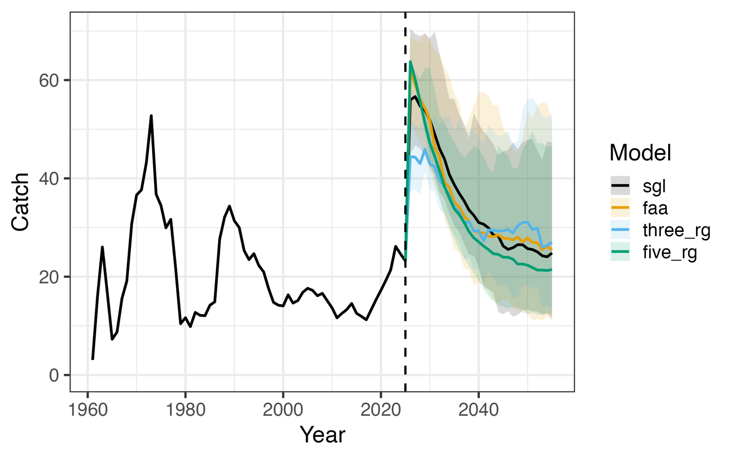
Figure 3E.8. Median trajectories and associated 95% simulation intervals of Alaska-wide catch (summed across regions and fleets) resulting from the application of different estimation models (EMs; colors) in the closed-loop simulation framework. The dashed vertical line depicts the start of the closed-loop projection period. Values to the left of the dashed line represent the historical conditoning period. Model names are as follows: sgl represents a single-region model, faa represents a fleets-as-areas model, three_rg represents the three-region model, and five_rg denotes the five-region reference model .

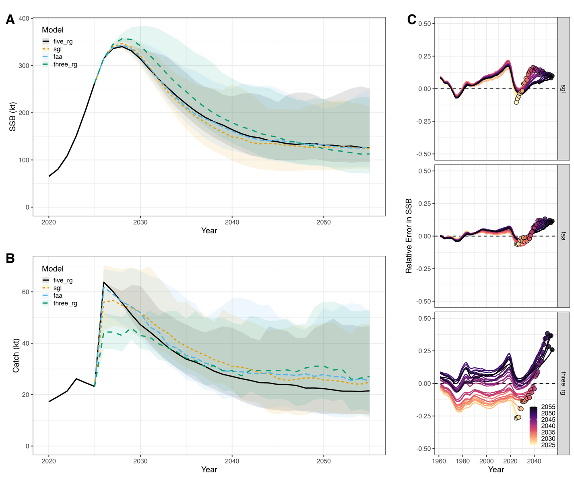Figure 3E.9. Summary of results from the closed-loop simulation framework employed. Panels A and B depict trajectories and associated 95% simulation intervals of Alaska-wide spawning stock biomass (SSB) (summed across regions) and catch (summed across regions and fleets) resulting from the application of different estimation models (EMs; colors) in the closed-loop simulation framework. Panel C shows the median relative error in SSB for each EM (row panels) by closed-loop projection year (colors), where the terminal year of each projection is indicated by a colored point.

